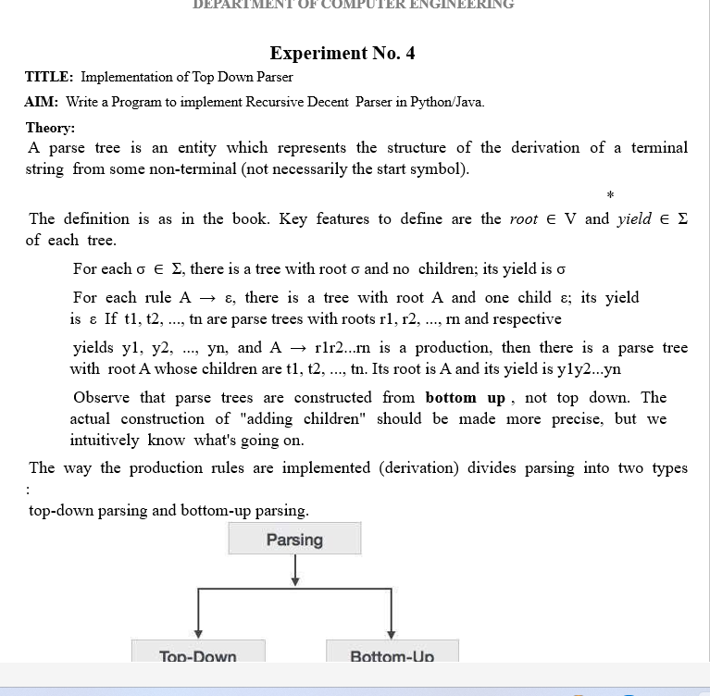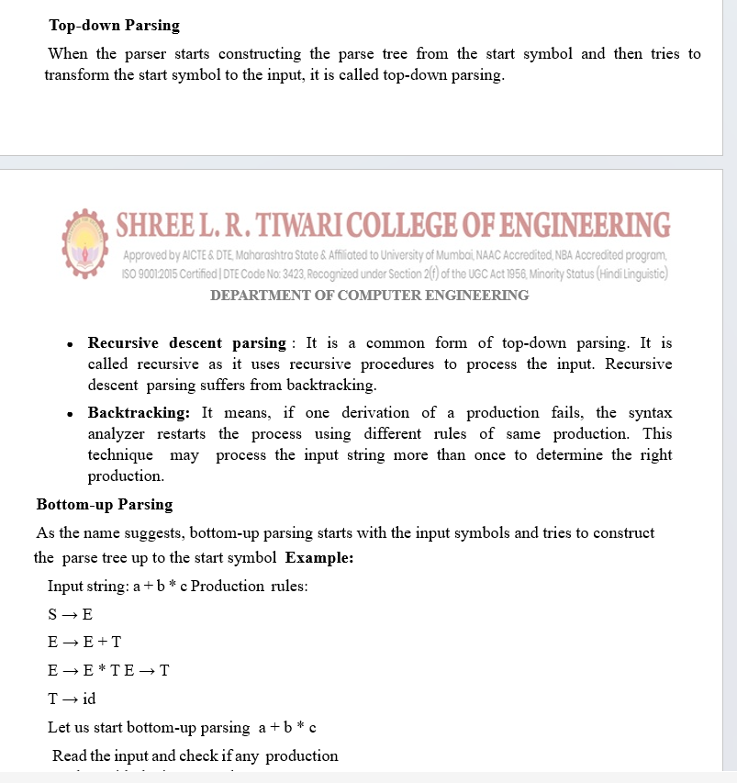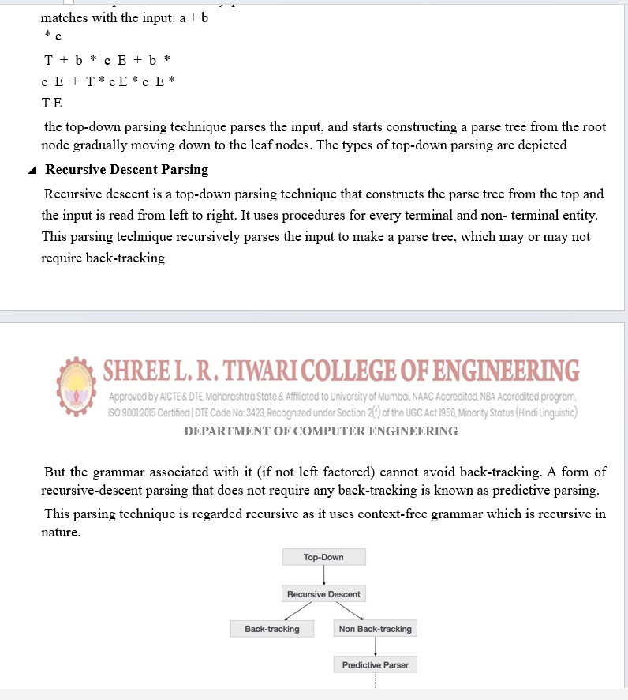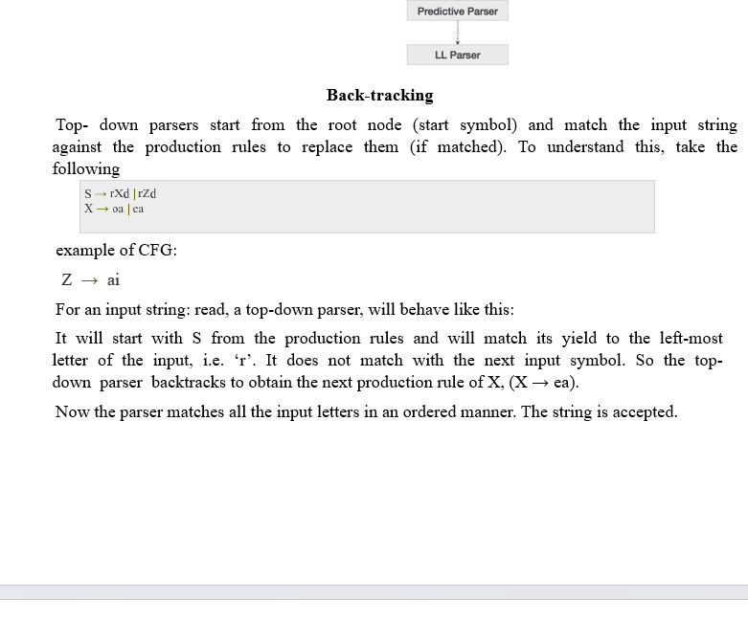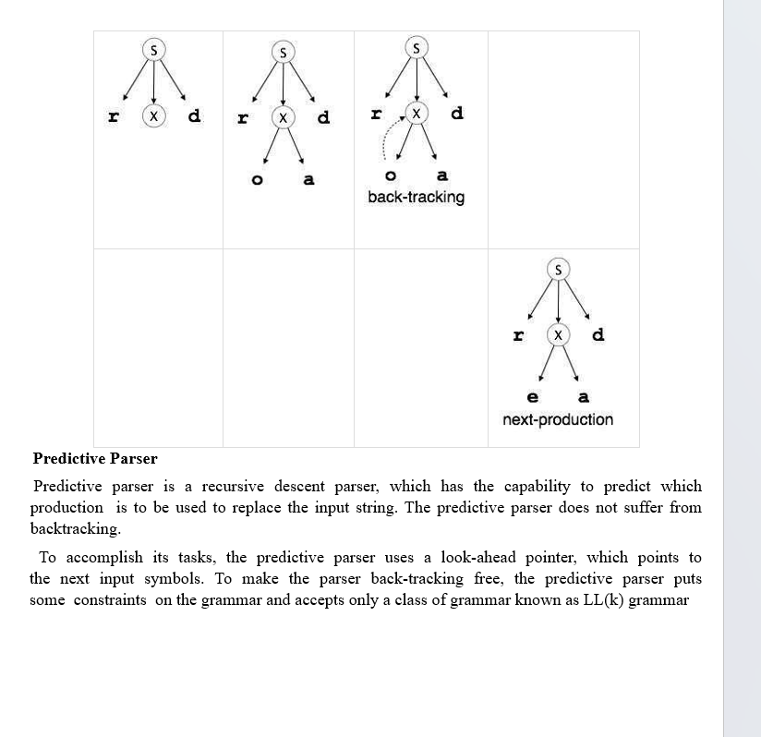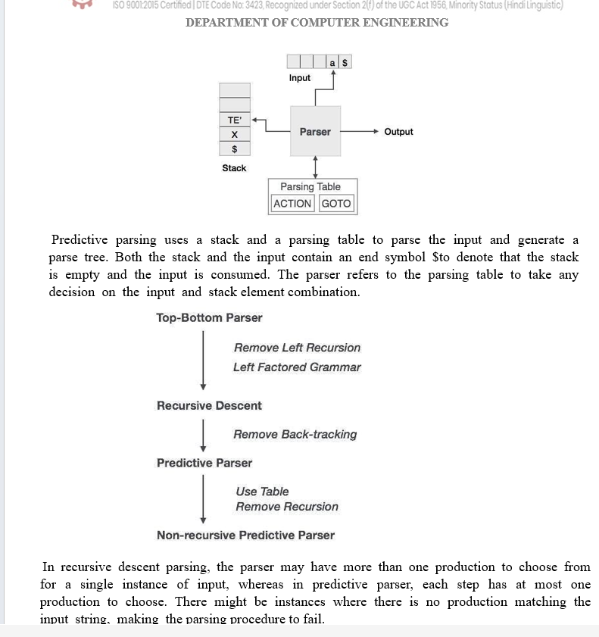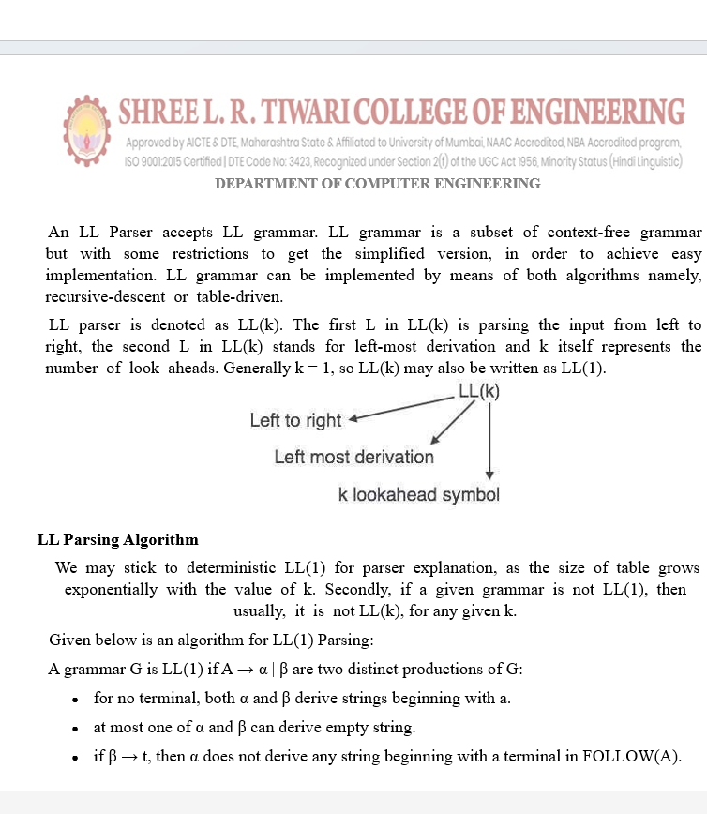

class LL1Parser:
def __init__(self, table, start):
self.table = table
self.start = start

def parse(self, input_str):
tokens, i = [], 0
while i < len(input_str):
tokens.append('id' if input_str[i:i+2] == 'id' else input_str[i])
i += 2 if input_str[i:i+2] == 'id' else 1
tokens.append('$')

stack, idx, parse_tree = ['$', self.start], 0, []
print(f"\n{'Stack':<30} {'Input':<30} {'Action'}\n{'-'*70}")

while stack:
top, current_input = stack[-1], tokens[idx]
print(f"{''.join(stack):<30} {''.join(tokens[idx:]):<30}", end=" ")

if top == current_input:
print(f"Match: {top}")
stack.pop()
idx += 1
elif top in self.table:
production = self.table[top].get(current_input)
if production:
print(f"Production: {top} -> {production}")
parse_tree.append(f"{top} -> {production}")
stack.pop()
if production != 'ε': stack.extend(reversed(production.split()))
else:
print(f"Error: No production for {top} with {current_input}")
return
else:
print(f"Error: Unexpected symbol {top} in stack")
return

if idx == len(tokens):
print("\nParse successful!\n\nParse Tree:")
print("\n".join(parse_tree))
else:
print("Error: Input not completely parsed")

parsing_table = {
'E': {'id': 'T E\'', '(': 'T E\''},
'E\'': {'+': '+ T E\'', ')': 'ε', '$': 'ε'},
'T': {'id': 'F T\'', '(': 'F T\''},
'T\'': {'+': 'ε', '*': '* F T\'', ')': 'ε', '$': 'ε'},
'F': {'id': 'id', '(': '( E )'}
}

parser = LL1Parser(parsing_table, 'E')
input_string = input("Enter input string (e.g., 'id+id*id'): ")
parser.parse(input_string)

output:

